FINAL REVIEW - APPENDICES
Build Track - Real Estate House Building Inventory and Progress Tracker
This technical appendix suite provides complete supporting evidence, core production source code listings, operational sub-functionality screen flows, the master QA test case execution matrix, and relational database DDL specifications that support the main technical review reports without cluttering the primary text.
Appendix A: Key Source Code Modules
Appendix A provides representative implementations of the core technical innovations highlighted in the implementation review:
A.1 Concurrency Control & Row-Level Inventory Locking (app.py)
Implements pessimistic locking using 'SELECT ... FOR UPDATE' inside an atomic database transaction to prevent inventory overselling:
-- Listing A.1: Python / Flask - Atomic Row Locking in outward_allocation()
@app.route('/materials/outward', methods=['POST'])
@role_required('admin')
def outward_allocation():
conn = get_db_connection(); cursor = conn.cursor(dictionary=True)
try:
mat_id = int(request.form.get('material_id')); qty = Decimal(request.form.get('quantity'))
cursor.execute("SELECT material_id, available_quantity, unit FROM materials WHERE material_id = %s FOR UPDATE;", (mat_id,))
mat = cursor.fetchone()
if not mat or Decimal(str(mat['available_quantity'])) < qty:
conn.rollback(); flash('Insufficient warehouse stock available.', 'danger'); return redirect(url_for('materials'))
cursor.execute("UPDATE materials SET available_quantity = available_quantity - %s WHERE material_id = %s;", (qty, mat_id))
cursor.execute("INSERT INTO material_allocations (material_id, house_id, quantity, allocation_date) VALUES (%s, %s, %s, NOW());", (mat_id, request.form.get('house_id'), qty))
conn.commit()
finally: cursor.close(); conn.close() # Deterministic connection release back to pool

A.2 Client-Side Laptop Webcam Hardware Integration (static/js/script.js)
Utilizes HTML5 MediaDevices API to access camera hardware, streaming video into a viewfinder and binding blobs via DataTransfer:
-- Listing A.2: JavaScript - HTML5 MediaDevices & Canvas DataTransfer Binding
const BuildTrackWebcam = {
start: async function(viewfinderId) {
const stream = await navigator.mediaDevices.getUserMedia({ video: { width: 1280, height: 720 }, audio: false });
document.getElementById(viewfinderId).srcObject = stream;
},
capture: function(videoElemId, canvasElemId, targetInputId) {
const video = document.getElementById(videoElemId), canvas = document.getElementById(canvasElemId);
canvas.width = video.videoWidth || 1280; canvas.height = video.videoHeight || 720;
canvas.getContext('2d').drawImage(video, 0, 0, canvas.width, canvas.height);
canvas.toBlob((blob) => {
const file = new File([blob], 'site_dispatch_proof.jpg', { type: 'image/jpeg' });
const dt = new DataTransfer(); dt.items.add(file);
document.getElementById(targetInputId).files = dt.files;
}, 'image/jpeg', 0.92);
}
};

A.3 MySQL Connection Pooling & Safe Resource Leasing (db.py)
Implements connection pool leasing with deterministic try-finally cursor cleanup to eliminate database connection leaks:
-- Listing A.3: Python - Centralized MySQL Connection Pooling and Execution
_connection_pool = mysql.connector.pooling.MySQLConnectionPool(pool_name="buildtrack_pool", pool_size=10, ...)
def query_db(query, args=(), one=False, commit=False):
conn = _connection_pool.get_connection(); cursor = conn.cursor(dictionary=True)
try:
cursor.execute(query, args)
if commit: conn.commit(); return cursor.lastrowid or cursor.rowcount
rv = cursor.fetchall(); return (rv[0] if rv else None) if one else rv
finally: cursor.close(); conn.close() # Safely returns leased connection back to pool

Appendix B: Screenshots of Core Sub-Functionalities & Screen Flow
Appendix B documents vital supporting sub-functionalities of BuildTrack that support the primary testing report, illustrating multi-site house construction progress tracking, material inventory thresholds, builder portal logging, and inward supplier dispatch verification:
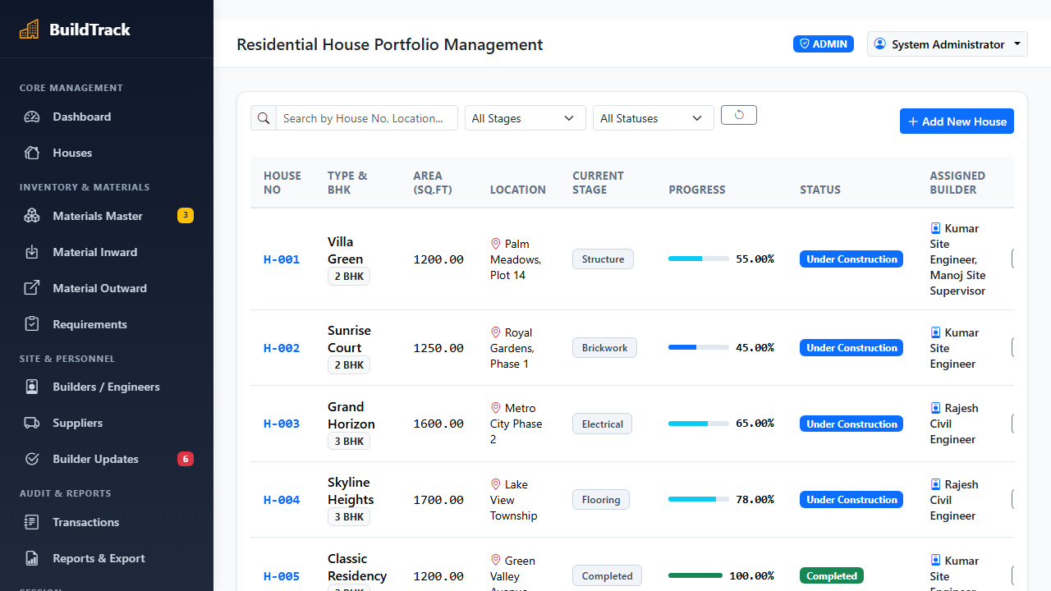  Figure B.1: House Construction Progress & Milestone Tracking  Demonstrates multi-site housing catalog (/houses) with active stage badges (Foundation Excavation, Plinth Beam Casting, Brickwork Masonry, Roofing Slab, Finishing), assigned Site Engineer, dynamic completion percentage bars, and plot milestone inspections. | 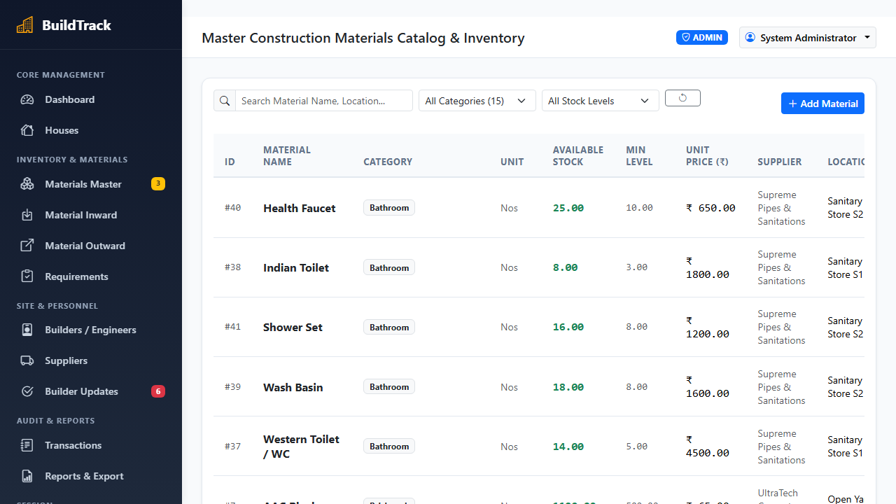  Figure B.2: Building Materials Inventory & Reorder Thresholds  Demonstrates building materials master inventory (/materials) tracking OPC Cement bags, TMT Steel rebar, River Sand, Red Clay Bricks, and Coarse Aggregate, featuring unit rates, current warehouse stock, minimum safety reorder thresholds, and dynamic alert badges.
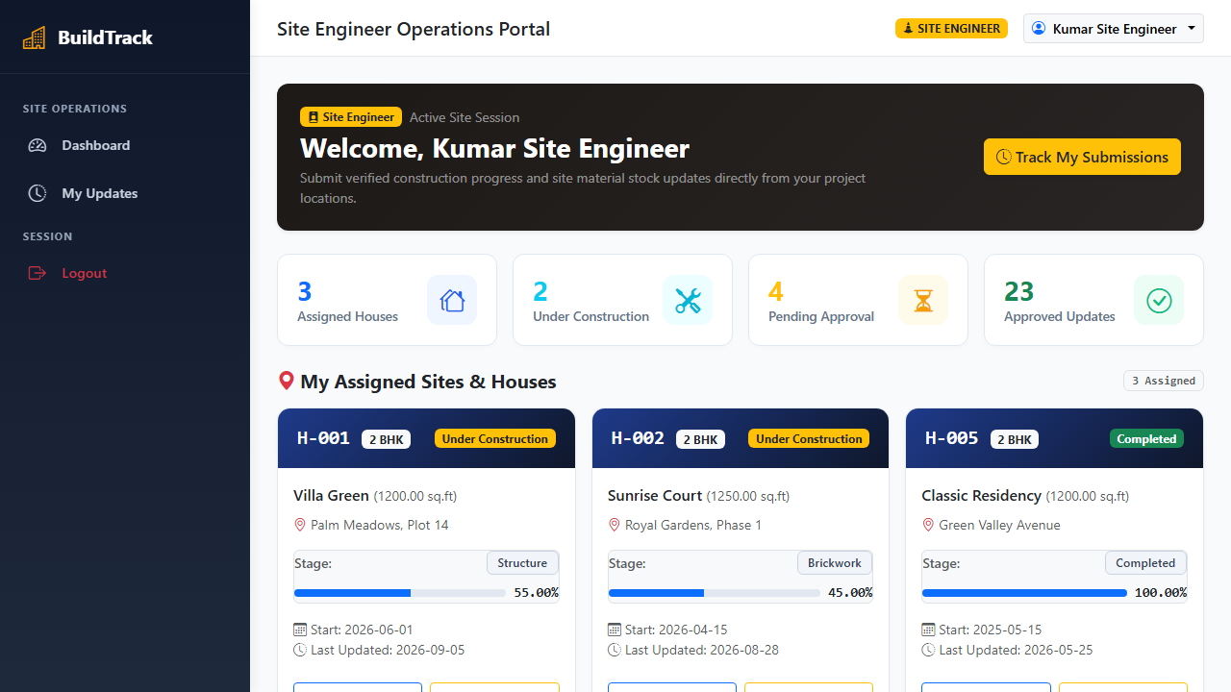  Figure B.3: Builder Job-Site Portal & Work Order View  Demonstrates assigned builder workstation portal (/builder/dashboard) showing allocated residential house plots, daily labor counts, material consumption request forms, and milestone progress logging actions. | 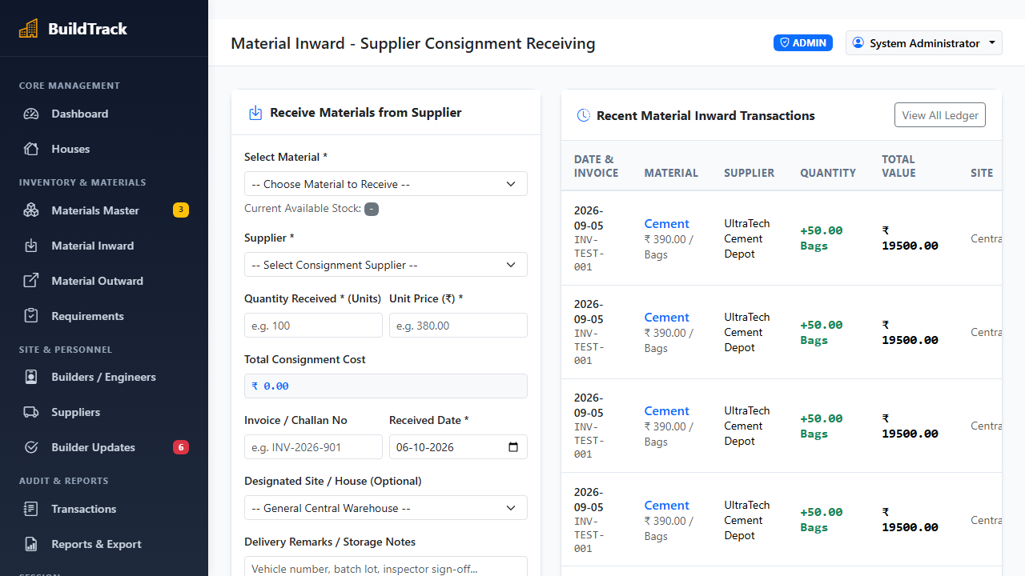  Figure B.4: Material Inward Challan & Delivery Dispatch Verification  Demonstrates supplier material receipt and inward challan logging (/inward) capturing external vendor identity (UltraTech Cement, Tata Tiscon Steel), commercial delivery truck registration numbers (e.g., `TN-38-BZ-4412`), invoice quantities, delivery dates, and camera verification proof.

Appendix C: Master Test Case Specification Table
Appendix C provides the exhaustive formal Quality Assurance verification matrix (TC-001 through TC-010). Each test case records preconditions, test steps, expected architectural behaviors, actual observed responses, and final verification verdicts:
Test ID | Actor / Module | Test Scenario & Input Steps | Expected Result | Actual Result | Verdict
TC-001 | Auth / Security | Register/Login with empty or invalid user password | Reject registration and display validation alert | Rejected with flash error message | PASS
TC-002 | Auth / Security | Login with valid Admin credentials (admin@buildtrack.com) | Hash verified via Scrypt/PBKDF2; session cookie issued with user role | Session created; redirected to Admin Dashboard | PASS
TC-003 | RBAC Route Guard | Builder attempts unauthorized /admin/materials/create access | Intercept request, deny access, return 403 Forbidden alert | HTTP 302 redirect with 'Access Denied' alert | PASS
TC-004 | Construction Admin | Admin creates new residential project (Villa Plot 14, 2400 sq.ft) | Insert house record; auto-seed chronological stages starting at Foundation (0%) | House saved; stage progress initialized | PASS
TC-005 | Builder / Webcam | Site engineer clicks 'Capture Site Photo' in milestone update modal | Browser prompts getUserMedia(); streams live video feed to viewfinder | Live video stream rendered in modal viewfinder | PASS
TC-006 | Milestone Progress | Submit milestone progress update with webcam photo and remarks | Update stage status to 'Completed'; recalculate house completion percentage bar | Milestone logged; progress percentage updated | PASS
TC-007 | Material Inward | Supervisor logs incoming supplier shipment (500 Bags OPC Cement) | Atomically increment warehouse stock; log supplier challan with vehicle number | Stock incremented; inward challan logged | PASS
TC-008 | Inventory Alert | Material warehouse stock drops below minimum safety threshold | Trigger dynamic amber warning badges on dashboard and reorder list | Amber low-stock alert badge displayed | PASS
TC-009 | Concurrency Lock | Two simultaneous outward allocations for remaining 10 Tons of TMT Steel | Pessimistic 'SELECT ... FOR UPDATE' serializes requests; 1st succeeds, 2nd rejected | First order succeeds; second receives out-of-stock | PASS
TC-010 | Reporting Subsystem | Admin requests automated site construction progress and inventory PDF report | Python ReportLab compiles active milestones, stock levels, and budget totals into PDF | Multi-page PDF generated with 100% data accuracy | PASS

Appendix D: Database Schema DDL & Visual Studio Code Execution Guide
Appendix D documents the relational database DDL statements for MySQL 8.0, followed by the step-by-step Visual Studio Code (VS Code) project execution and review demonstration procedure:
D.1 MySQL 8.0 Relational Table Definitions (InnoDB Engine)
-- SQL - MySQL 8.0 Relational Table Definitions (InnoDB Engine)
-- MySQL 8.0 InnoDB Relational Table DDL
CREATE TABLE users (user_id INT AUTO_INCREMENT PRIMARY KEY, full_name VARCHAR(100), email VARCHAR(100) UNIQUE, password_hash VARCHAR(255), role ENUM('admin','builder') DEFAULT 'builder', phone VARCHAR(20), status ENUM('Active','Inactive') DEFAULT 'Active');
CREATE TABLE houses (house_id INT AUTO_INCREMENT PRIMARY KEY, house_name VARCHAR(120) NOT NULL, location VARCHAR(150), total_budget DECIMAL(12,2), current_stage VARCHAR(60), completion_percent INT DEFAULT 0, site_engineer_id INT, FOREIGN KEY (site_engineer_id) REFERENCES users(user_id) ON DELETE SET NULL);
CREATE TABLE materials (material_id INT AUTO_INCREMENT PRIMARY KEY, material_name VARCHAR(100) NOT NULL, category VARCHAR(60), unit VARCHAR(20), unit_price DECIMAL(10,2), available_quantity DECIMAL(10,2), minimum_threshold DECIMAL(10,2), status ENUM('In Stock','Low Stock','Out of Stock') DEFAULT 'In Stock');
CREATE TABLE material_allocations (allocation_id INT AUTO_INCREMENT PRIMARY KEY, material_id INT, house_id INT, quantity DECIMAL(10,2), allocation_date DATETIME, allocated_by INT, FOREIGN KEY (material_id) REFERENCES materials(material_id), FOREIGN KEY (house_id) REFERENCES houses(house_id));
CREATE TABLE inward_records (inward_id INT AUTO_INCREMENT PRIMARY KEY, material_id INT, supplier_name VARCHAR(100), vehicle_no VARCHAR(30), invoice_no VARCHAR(50), quantity DECIMAL(10,2), delivery_date DATE, photo_path VARCHAR(255), FOREIGN KEY (material_id) REFERENCES materials(material_id));
CREATE TABLE construction_stages (stage_id INT AUTO_INCREMENT PRIMARY KEY, house_id INT, stage_name VARCHAR(80), stage_order INT, status ENUM('Pending','In Progress','Completed') DEFAULT 'Pending', start_date DATE, completion_date DATE, FOREIGN KEY (house_id) REFERENCES houses(house_id) ON DELETE CASCADE);
CREATE TABLE stage_updates (update_id INT AUTO_INCREMENT PRIMARY KEY, stage_id INT, updated_by INT, update_date DATE, progress_notes TEXT, photo_filename VARCHAR(255), FOREIGN KEY (stage_id) REFERENCES construction_stages(stage_id), FOREIGN KEY (updated_by) REFERENCES users(user_id));

D.2 Visual Studio Code (VS Code) Execution & Demonstration Procedure
The project is configured for execution within Microsoft Visual Studio Code on Windows:
-- PowerShell / VS Code - Step-by-Step Environment Setup & Execution Procedure
# 1. Launch Visual Studio Code in Project Workspace
code "C:\Users\Santhosh Rathinam\.gemini\antigravity\scratch\real_estate_inventory"
# 2. Select Python Interpreter in VS Code (Ctrl + Shift + P -> 'Python: Select Interpreter')
# Ensure Python 3.12 (or virtual environment .venv\Scripts\python.exe) is selected
# 3. Open VS Code Integrated Terminal (Ctrl + ~) & Install Dependencies
pip install -r requirements.txt
# 4. Verify / Initialize MySQL 8.0 Database Schema via VS Code Terminal
python -c "from db import init_db; init_db()"
python seed_data.py # Seeds initial residential plots, master building materials, and user credentials
# 5. Execute Web Application in VS Code
# Option A: Press 'F5' or 'Ctrl + F5' to Run with Debugging
# Option B: In VS Code Integrated Terminal, run:
python app.py # Launches WSGI development server at http://127.0.0.1:5000
# 6. Open Browser (Chrome/Edge) at http://127.0.0.1:5000
# Demonstration Review Credentials:
# - Administrator: admin@buildtrack.com / Admin@123
# - Site Builder: kumar@buildtrack.com / Builder@123

